Brace Covers
Cut: Fabric (S) 2 – 5 ¾” x 7” Velcro (S) 1 set – 4 ½”
(M) 2 – 6 ¾” x 7 ¾” (M) 1 set – 6”
(L) 2 – 7 ½” x 6 ¾” (L) 1 set – 6”
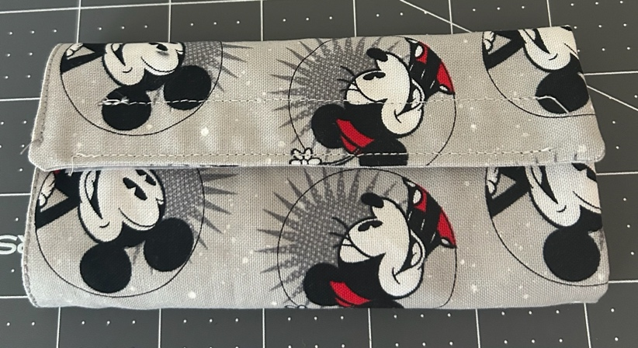
Finished size: (S) 5 ¼” x 6 ½”
(M) 6 ¼” x 7 ¼”
(L) 7 x 6 ¼”

Sew ¼” seam allowances.

Small and Medium Covers:
1. Sew right sides together, leave a 2 ½’ inch opening. Clip corners. Turn right side out, push out corners to form square. Press and sew opening closed.
- Pin Velcro on the short ends, on opposite sides. (Top of front and bottom of back)
Large Cover:
1. Sew fabric the same as for the small covers.
2. Pin Velcro onto longer sides of rectangle. Top of front and bottom of back.
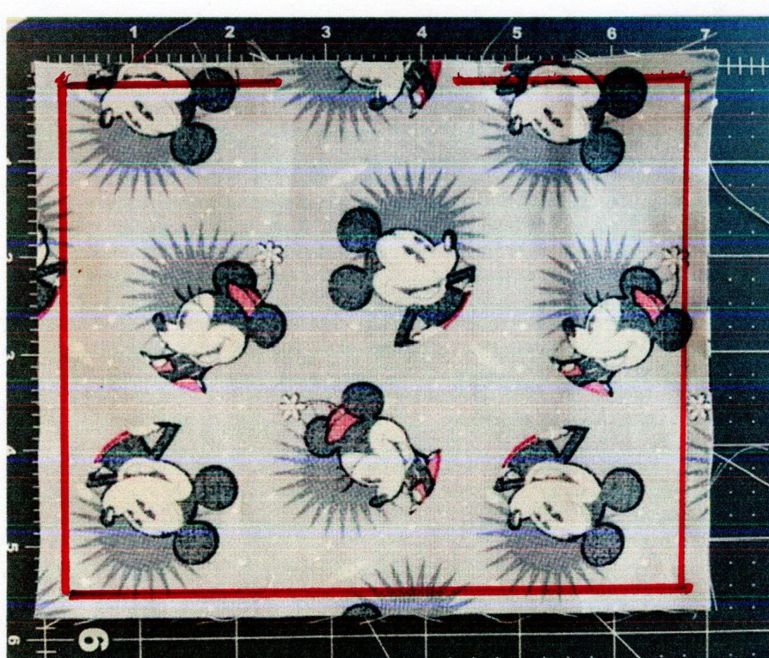
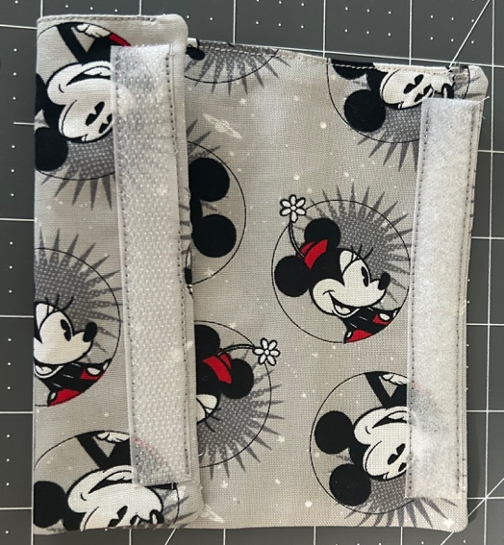
- 2.

