Looking forward to the Holidays

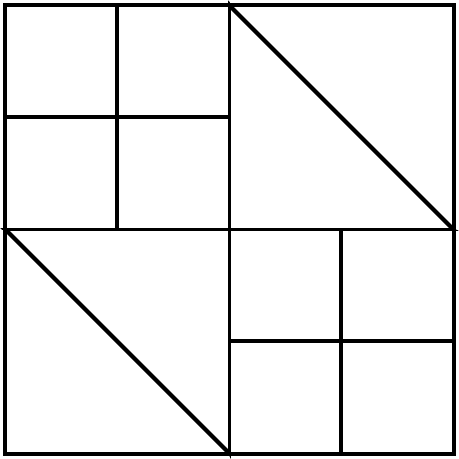
C
C
C
C
D
D
D
D
A
A
B
B

November 2025 Block of the Month

Reds, greens, silvers, gold, holiday prints - Light background

A – light background: cut 1 - 7” square, cut in half diagonally
B – holiday print: cut 1 - 7” square, cut in half diagonally
C – cut 4 - 3½” squares to coordinate with the holiday print you are using. I used red to coordinate with my holiday print fabric.
D – cut 4 - 3½” squares to coordinate with the holiday print you are using. I used green to coordinate with my holiday print fabric.

Stitch A and B together, to make 2. Square to 6 ½” x 6 ½”
Piece the C and D squares together to make pairs.
Sew the 4 pairs together to make 2 - 4 patches.
Piece them together, along with the A/B squares to make a 12½” squares, following the graphic above.

Make as many as you wish and bring them to the December SMQA holiday luncheon and receive a ticket for each one. A ticket will be drawn during the meeting and you might be the lucky winner. Good Luck !

